# Airplane Seating Arrangement

Write a program that helps seat audiences in a flight based on the following input and rules.

# Rules for seating

* Always seat passengers starting from the front row to back, starting from the left to the right.
* Fill aisle seats first followed by window seats followed by center seats (any order in center seats).
* Passenger_id with a prime number should be given first priority.
* Passenger_id with a number multiple of 2 power n will be given second priority.

# Input

* A 2 dimension input array that represents the rows and columns
  + Example **[[3,2], [4,3], [2,3], [3,4]]**
* List of passenger id’s will be given.

# Example [29,59,14,11,3,13,15,18,12,16,6,17,7,47,61,5,21,2,41,9,10,8,19,1,4]

**Input Constraints**

* 1 <= Rows, Columns <= 103
* 1 <= Passenger_id <= 109
* Array size of passenger_id will not exceed 109

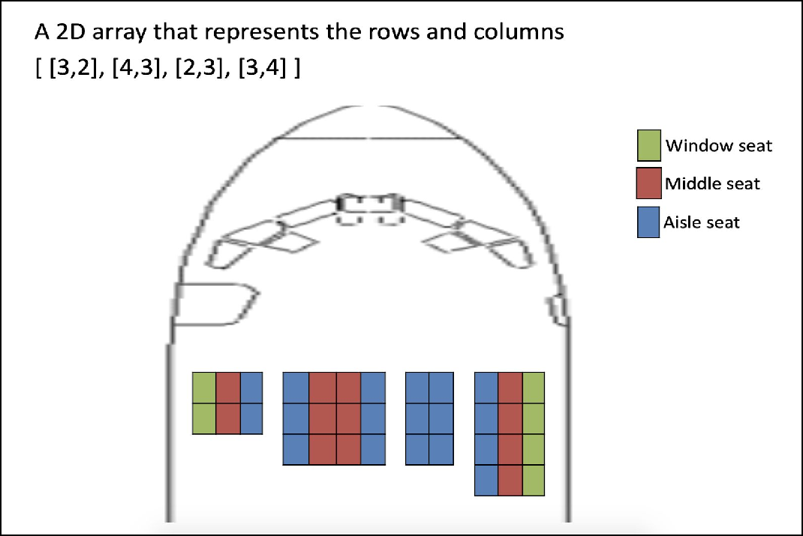

**O utput**

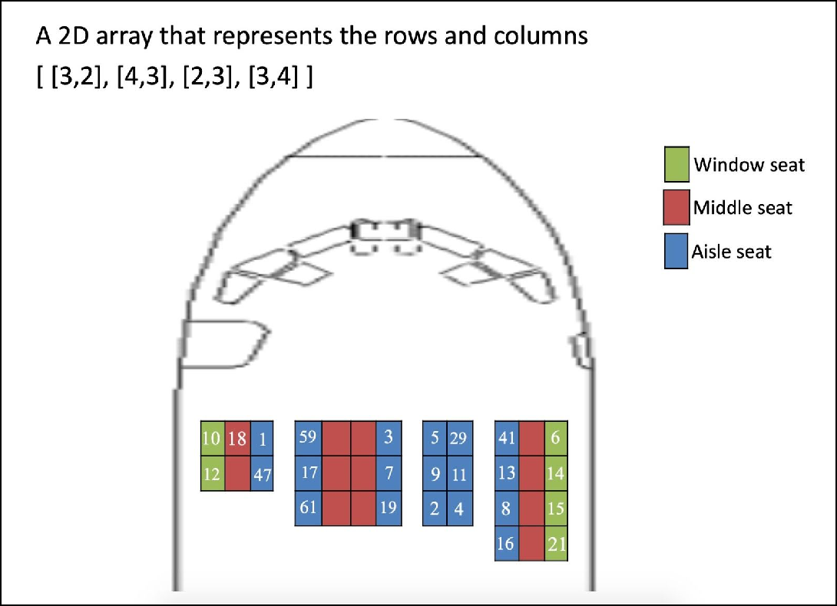

**Description of Code:**

Lines 5 to 14: Checking whether the given numbers are prime

Lines 16 to 25: Checking whether the given numbers are multiples of 2 power n

Lines 26 to 47: Getting the input for matrices

Lines 49 to 58: Initializing the seat list

Lines 60 to 73: Reading the passenger ID and separating it as prime, multiples of 2 power n and other

Lines 75 to 137: Calculating the tuples corresponding to Window , Aisle and Center seats

Lines 138 to 142: Printing the tuples corresponding to window , aisle , center seats

Lines 143 to 242: Printing as per the seating arrangements.